The Gadsden Purchase and a Visit to Los Nogales in 1855
Pima-Maricopa Irrigation Project Education Initiative
2005-2006

Restoring water to ensure the
continuity of the Akimel O’otham
and Pee Posh tradition of agriculture

Re

When Bartlett left the Pima villages for Tucson, in July 1852, he found the Spanish presidio in a state of siege. When he arrived in San Antonio, Texas, in January 1853, he was relieved of his command, with William Emory completing the boundary work under the field command of General Robert Blair Campbell. President Franklin Pierce, however, did not recognize the final Bartlett-Condé boundary line in New Mexico. Using an ambiguity in the 1848 Treaty of Guadalupe Hidalgo, Pierce—seeking additional Mexican territory for a transcontinental railroad to California—sent James Gadsden to Mexico to negotiate with President Antonio Lopez de Santa Anna for land south of the Gila River. Gadsden arrived in Mexico City in the summer of 1853 to correct the boundary errors and seek additional land for a railroad.
Part 64

While Gadsden sought to purchase enough land to put an American port on the Gulf of California, Santa Anna agreed only to sell enough land for the Southern Pacific Railroad along the 32nd parallel. Under the terms of the Gadsden Purchase Treaty, Mexico ceded to the United States a strip of land south of the Gila River from the Rio Grande on the east to a point twenty miles below the confluence of the Gila and Colorado rivers. The area included 45,535 square miles or 29,142,400 acres and cost the United States $10,000,000.
To survey the new boundary line, Emory, then Brevet Major, Corps Topographical Engineers, was appointed Commissioner and astronomer with José Salazar Larregui appointed commissioner on the part of Mexico. Emory began working west from El Paso in December 1854, with Lieutenant Nathaniel Michler surveying east from the Colorado River. Emory and Michler met in camp near “Los Nogales” where nine Pima, Maricopa and Papago leaders met with the Americans to discuss the effects of the new international boundary line.
In June 1855, Azul led the delegation to Los Nogales, where he met with Emory to discuss “the effect upon them and their interests of the treaty with Mexico,” by which they found themselves under the jurisdiction of the United States. Emory, aware the Pima and Maricopa had “a just claim to their lands,” warned the secretary of war that “if dispossessed they will make war on the frontier of a very serious character.” Emory understood and recognized the military threat the Pima and Maricopa posed if deprived of their rights. “They have always been kind and hospitable to emigrants passing from the old United States to California, supplying them freely, and at moderate prices.” To this end, the Major urged Congress enact legislation “securing these people in their rights.” Emory’s official report gave an account of this visit.

“Camp at Los Nogales, June 29, 1855

Capt. Antonio Azul, head chief of the Pimos; Capt. Francisco Luke, Coco Maricopa chief; Capt. Malai, Coco Maricopa chief; Capt. Shalan, a chief of the Gila Pimos; Capt. Ojo de Burro, war-chief of Pimos; Capt. José Victoriano Lucas, head chief of the San Xavier Pimos; Capt. José Antonio, chief of the San Xavier Pimos, have this day visited my camp for the purpose of ascertaining in what manner the cession of the territory, under the treaty with Mexico, will affect their rights and interests. I have informed them that, by the terms of the treaty, all the rights that they possessed under Mexico are guarantied (sic) to them by the United States; a title to lands that was good under the Mexican government is good under the United States government. I informed them that, in the course of five or ten months, perhaps sooner, the authorities of the United States would come into the ceded territory and relieve the Mexican authorities; until that time, they must obey the Mexican authorities, and co-operate with them, as they have done heretofore, in defending the territory against the savage Apaches.
I have examined the testimonials given by numerous American emigrants to Azul and his captains, bearing testimony to the kindness and hospitality of himself, and the Pimo and Coco Maricopa Indians generally. I can myself bear testimony to the truth of these statements. I therefore call upon all good American citizens to respect the authority of Azul and his chiefs.
W. H. Emory, U.S. Commissioner, Major U.S.A.

Antonio Azul alias Che-T-A-Ca-Moose
Francisco Luke “ See-Cool-Mat-Hais
Malai
Shalan, “ Ki-Mah
Ojo de Burro, “ Wal-La-Whoop-Ka
Tabaquero, “ Vir-Ah-Ka-Ta
La Boca de Queja, “ Ki-Ho-Chin-Ko
José Victoriano Lucas
José Antonio”

Emory then presented Azul and the other chiefs with a copy of the report and some gifts of blankets, clothe and silver dollars. In a dispatch to the commander of the Military Department of New Mexico, Emery elaborated on his visit:

“The Pimo Indians with their neighbors & friends the Maricopas, mustering it is said, two thousand warriors & at present acting under the authority of the Mexican Government, as the advanced guard of the Mexican outposts, visited my camp and manifested much anxiety to know if the transfer of Territory would affect the grants of lands ceded them by Mexico, which they now cultivate with so much success.

I did not hesitate to tell them their authority remained intact for the present, and that it was my impression titles under Mexico were secured them by the Treaty. I have known these Indians since 1846 and recommend them to the authorities as worthy of all confidence. They are important auxilaries in the defense of the new frontier.”

In a separate report, Michler observed the Pima were “further advanced in the art of agriculture, and are surrounded with more comforts” than any other tribe he had visited. In addition to being skilled warriors, they were “good husbandmen and farmers, and work laboriously in the field.” The women were “very industrious” and lived in “very comfortable” homes. The people were the owners of fine horses, mules, oxen, cows, pigs and poultry, leading Michler to conclude they were “a wealthy class of Indians.”
Nonetheless, Antonio Azul had much with which to be concerned. With the Pima and Maricopa irrigating an abundance of rich fields of food and fiber crops—with wheat ripening at the time of Michler’s visit in May—Michler understood the threat to the Pima and Maricopa. In fact, Michler reported that the Indians “were anxious to know if their rights and titles to lands would be respected by our government, upon learning that their country had become part of the United States.” Under Mexican adminstration, the Indians had occupied their lands without molestation and used the life-giving waters of the Gila without contest. Azul, aware of the large number of emigrants who passed through the villages during the California Gold Rush, was well aware of the potential disruption of his people’s way of life if large numbers of emigrants should settle near or above the villages.
Thus, the meeting at Los Nogales was an important one that set the tone for the political and social relationship between the Pima and Maricopa and the United States. When Azul and the other leaders left Los Nogales, they had been assured they would be secure in all of their rights. Azul had every expectation that his people’s lands and resources would be respected and their agricultural production would continue to increase. Only time would tell if the assurances received at Los Nogales would be fulfilled.

The Gadsden Purchase Map
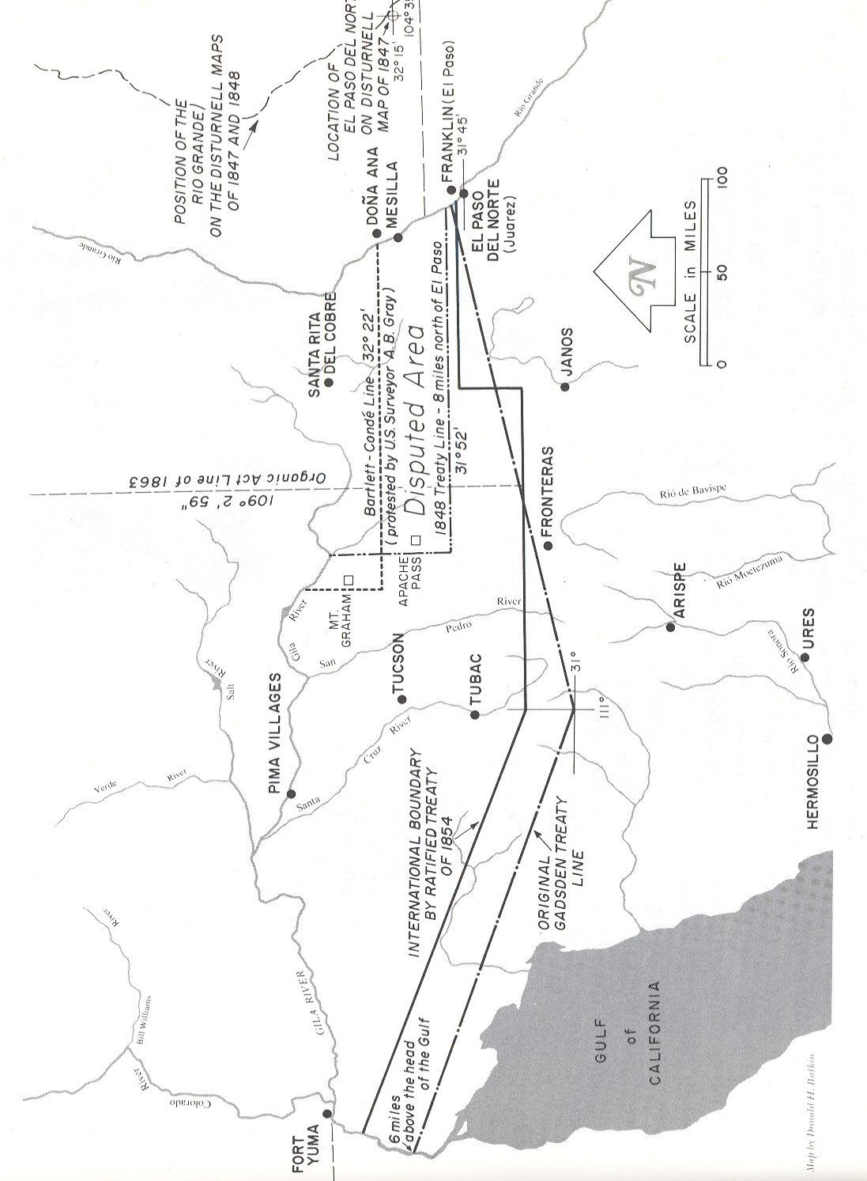

Teacher Plan for “The Gadsden Purchase and a Visit to Los Nogales in 1855”

Objectives

Students will be able to:

- Explain and describe the substance of Azul’s visit with Emory at Los Nogales.

- Identify the potential effects—pro and con—of the Gadsden Purchase on the Pima and Maricopa.
Terms to know and understand

- Siege
- Transcontinental
- Delegation
- Husbandman
- Testimonial

Critical Thinking:

- Antonio Azul and eight other leaders traveled to Los Nogales (present-day Nogales) to determine the effects of the Gadsden Treaty on Pima and Maricopa rights and interests. If you had been one of these leaders, what would have been among your most important concerns? Why? Recognizing that the Emory letter represents his interpretation or view of the meeting, do you think Azul might have discussed other issues? What might these issues have been?
Activities:

- Divide the class into three groups. One will represent Major Emory and the United States. Have the group identify the primary interests of the United States for acquiring the Gadsden Purchase lands. The second group will represent the Pima and Maricopa. This group will also identify and prepare a list of concerns and issues that would be important to it. Make sure both groups have a clear idea of what it is they wanted. Recognize that Emory was simply surveying the line to which the United States and Mexico had already agreed. The third group will be interpreters. Whatever Emory stated was translated into Spanish and from Spanish into Maricopa and from Maricopa to Pima. Whatever Azul stated went from Pima to Maricopa to Spanish to English. What challenges and concerns are raised from this type of discussion?

About P-MIP

The Pima-Maricopa Irrigation Project is authorized by the Gila River Indian Community to construct all irrigation systems for the Community. When fully completed, P-MIP will provide irrigation for up to 146,330 acres of farmland. P-MIP is dedicated to three long-range goals:
- Restoring water to the Akimel O’otham and Pee Posh.
- Putting Akimel O’otham and Pee Posh rights to the use of water to beneficial use.
- Demonstrating and exercising sound management to ensure continuity of the Community’s traditional economy of agriculture.

